Goldade Flooring & More

GF____

User’s Guide to the new

Ordering System

By: Heather Goldade

10/18/15 week 7

CIS 355

1. Getting Started!

This new program was designed to make processing customer orders quicker and more efficient than before! Just select the customers’ preferred flooring, the floor’s dimensions, and the customer information. This new program will save the order and will also allow the user to display all current orders.

This program has four separate tabs. Each tab will allow the user to progress through the program and will be clearly labeled.

Go to Page 4 Go to Page 5

Go to Page 3 Go to Page 6

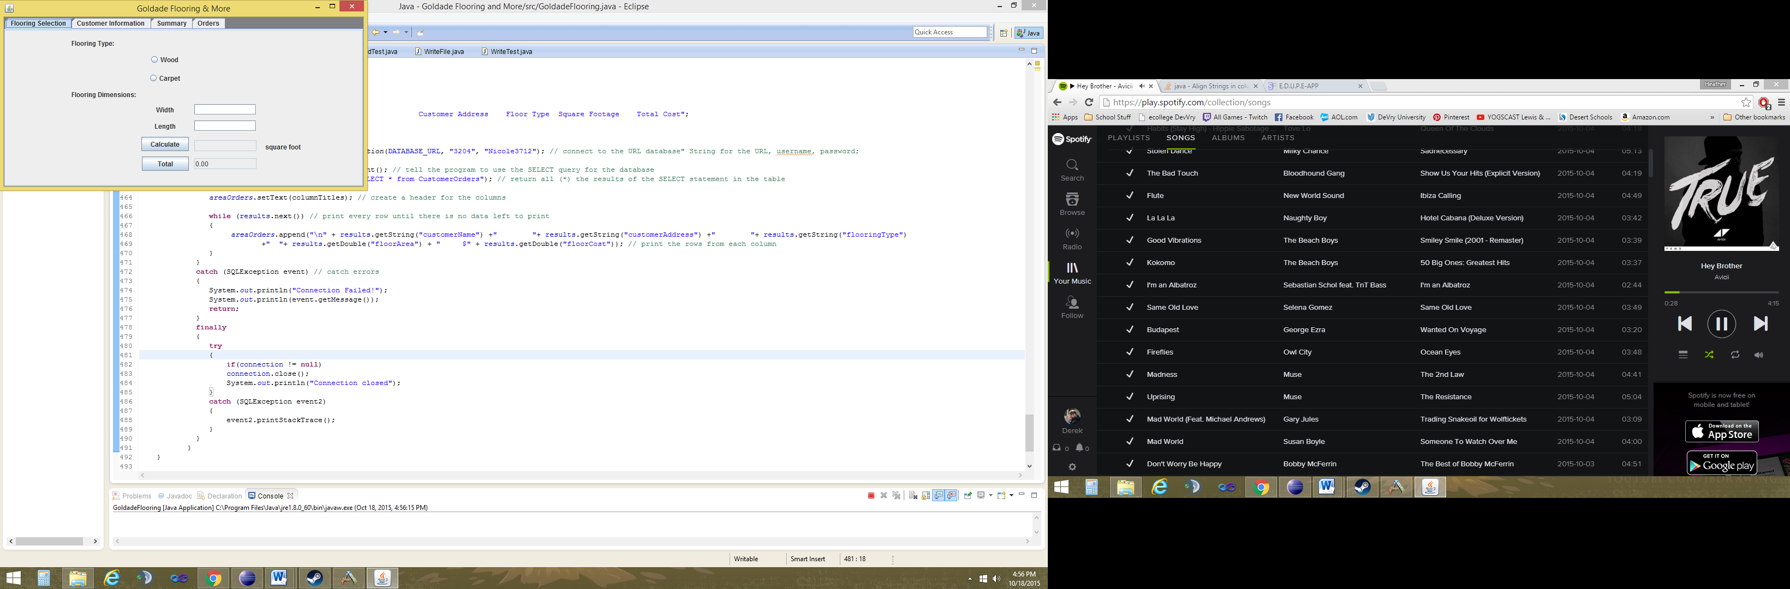

**Press ok to get started!**

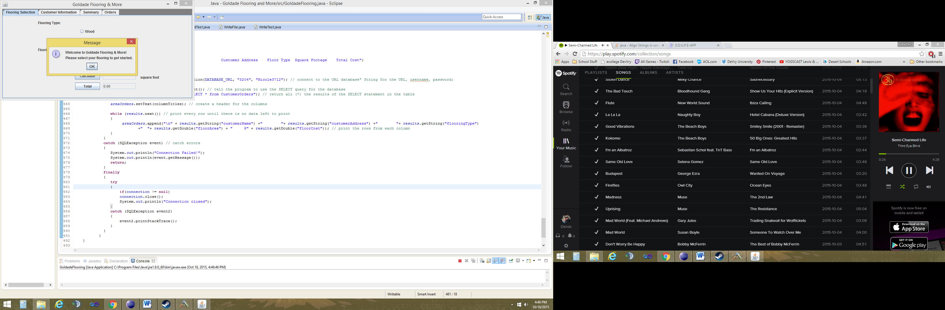

1. Floor Selection

* First, select the flooring type that the customer would like to order.
* Next, enter the carefully measured **width** and the **length** into the text boxes with their respective labels.
* Once the measurements are entered, click the **Calculate** button. This will calculate the area in square footage that the customer would like to order.

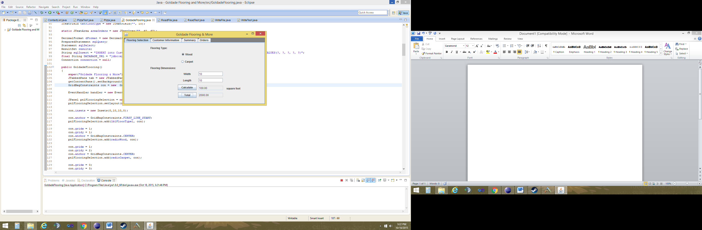

* Finally, the **Total** button will calculate the total price that will be charged to the customer. When you are ready, click the Customer Information tab to continue the order.

1. Customer Information

Once you get to this tab, you can enter the customer’s information

* You can enter the first and last name
* The Street Address
* City
* The State abbreviation
* And lastly the zip code

# NOTE:

# **Before** clicking the **Submit** button, carefully look over the customer’s information to make sure everything is correct being saved!

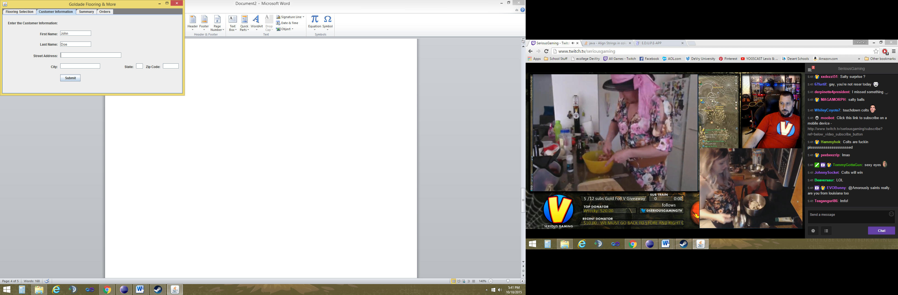

Click **Submit** when you are ready to save the order.

1. Customer Information

Once you click the **Submit** button on the Customer Information tab, you will be able to view the customer’s information that was saved to the database.

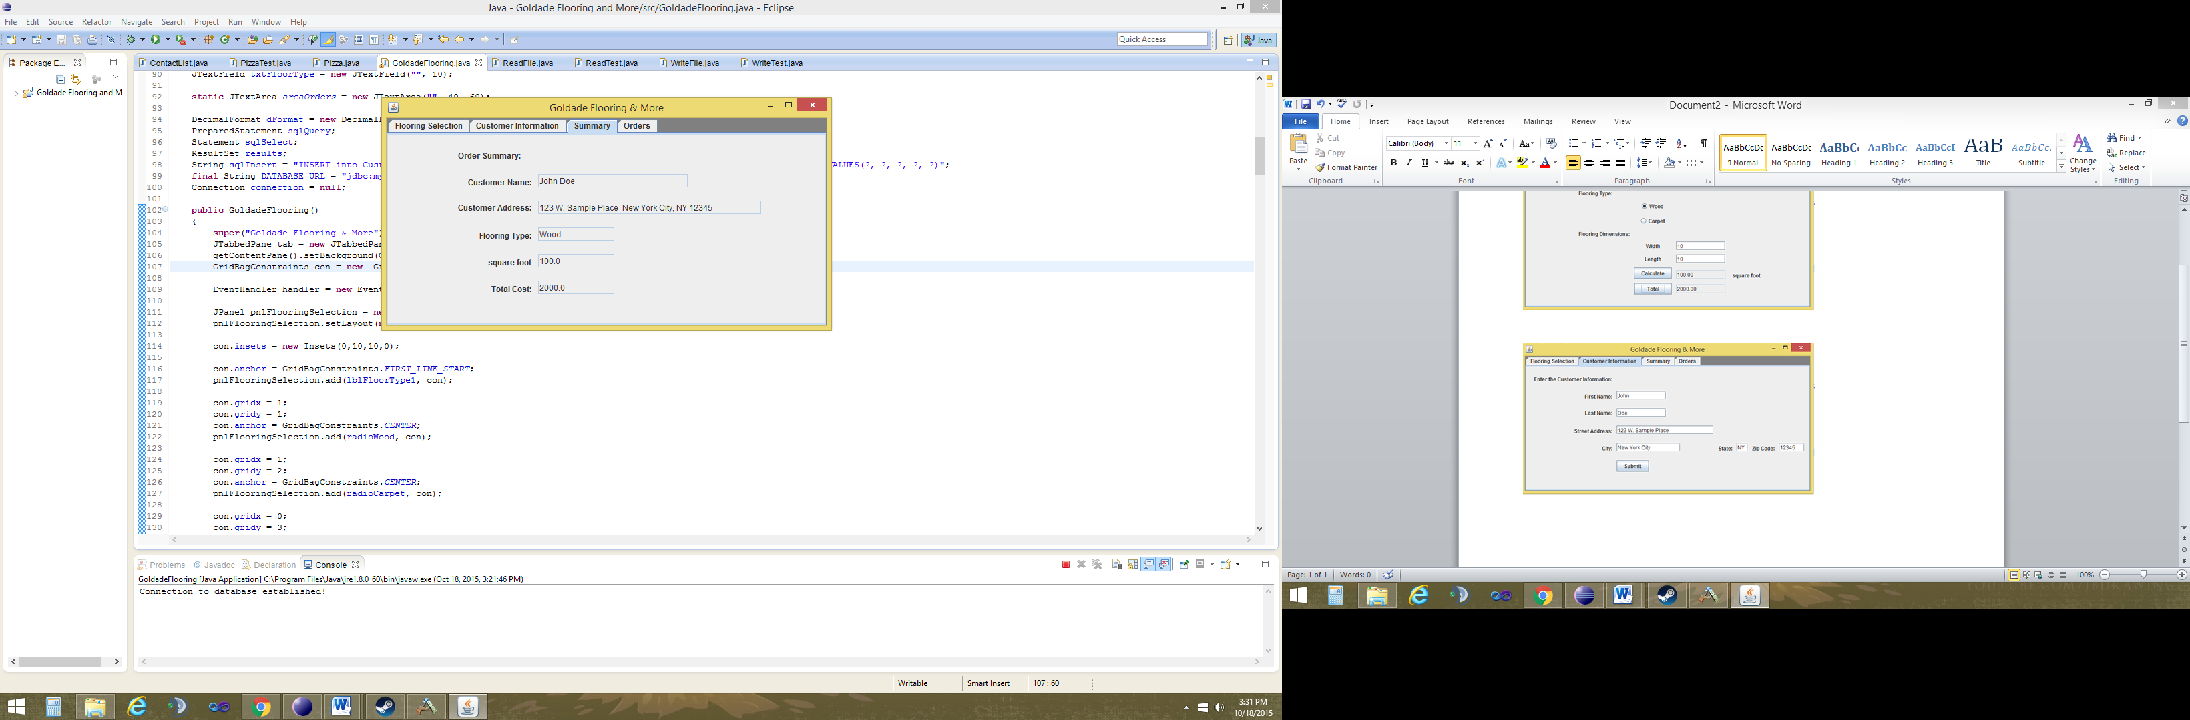

The last tab, **Orders**, allows you to view all of the current customer orders that are saved to the database and awaiting fulfillment. Just click the **View Orders** button.

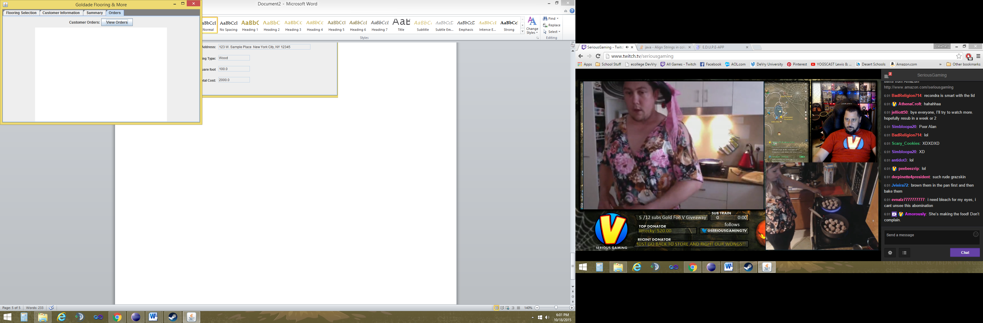

A Note on Error Messages:

If any of the fields are filled in with improper information, the following error message will appear:

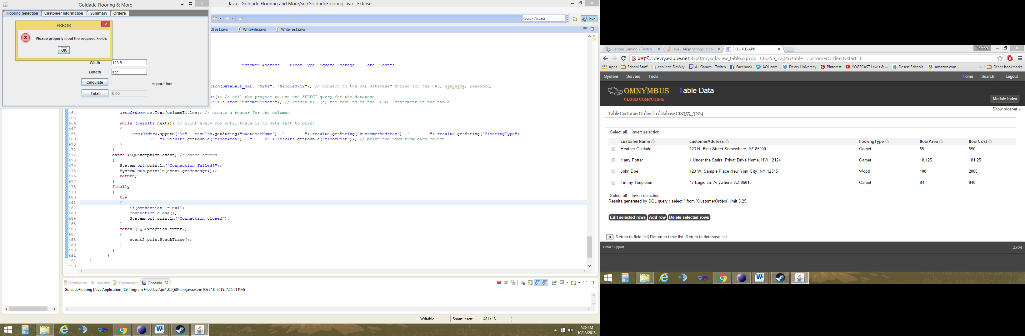

The user’s input is alphanumeric. **Length** should be numeric values only.

If this message appears, click **OK** and carefully check that all the boxes are filled in and they are the proper numeric or alphanumeric characters.

If you have any further questions or concerns, please call us at: (555) 550-0505.